Grand Tetons Campsite Raster Suitability Analysis
By Joachim Vogl

Binary overlay output showing the trails overlayed on a terrain map:

Shows the suitable camping areas in orange and then in faint green is the road area/trails in which people can go through

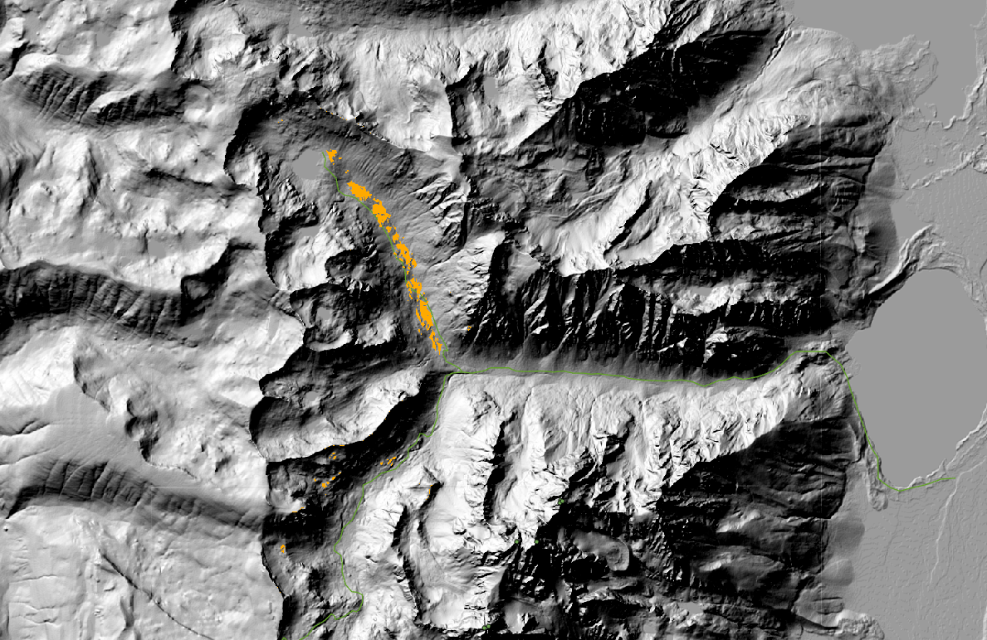

Weighted overlay output:

Closeup of the campsites showing the mountain peaks visible in the area and other topographic features such as the lakes

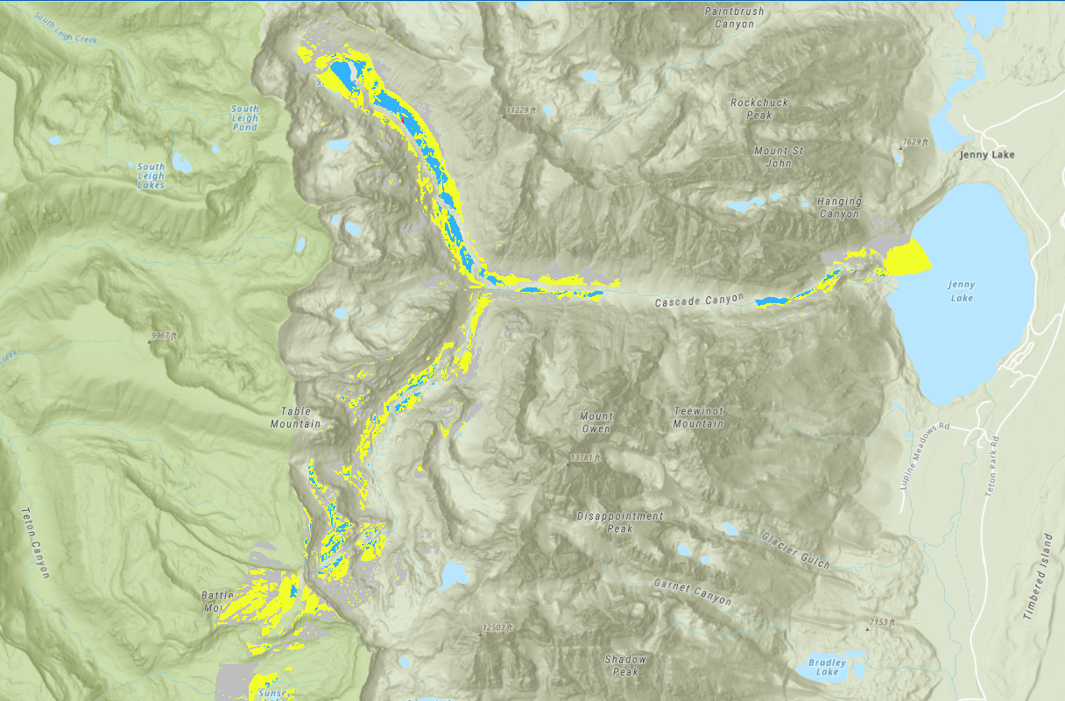

Binary and weighted output raster attribute tables:

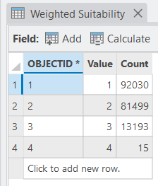
Weighted output raster attribute table

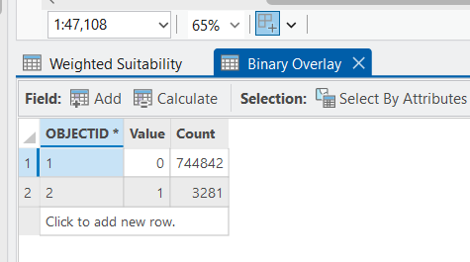
Binary raster attribute table

Report the total areas in m² and acres for each final campsite suitability value:

Assuming 10m × 10m cell size (100 m² per cell), a new campsite will have:
- Area = 3,281 × 100 = 328,100 m²
- Area = 328,100 × 0.000247105 = 81.07 acres

Value | Suitability | Count (cells) | Area (m² ) | Area (Acres)
4 | Excellent | 15 | 1500 | 0.37
3 | Good | 13193 | 1319300 | 326.00
2 | Ok | 81499 | 8149900 | 2013.78
1 | Poor | 92030 | 9203000 | 2274.10

Calculations:
Excellent:
- 15 × 100 = 1,500 m²
- 1,500 × 0.000247105 = 0.37 acres
Good:
- 13,193 × 100 = 1,319,300 m²
- 1,319,300 × 0.000247105 = 326.00 acres
Ok:
- 81,499 × 100 = 8,149,900 m²
- 8,149,900 × 0.000247105 = 2,013.78 acres
Poor:
- 92,030 × 100 = 9,203,000 m²
- 9,203,000 × 0.000247105 = 2,274.10 acres

What, if any, issues do you see with the output? Can you find any areas in your output are clearly unusable for camping? Do you have suggestions for additional criteria to include to make this analysis better?

The binary overlay shows suitable areas in orange that may include steep cliff faces or rocky terrain that appears flat in the slope analysis but is actually unsuitable for pitching tents. Some suitable pixels appear isolated from the trail, which could create access difficulties for campers. The weighted overlay reveals narrow corridors of "excellent" suitability that may be too constrained for actual campsite development, and some highly suitable areas like in flatter regions are actually just on ridgelines where it could be super rocky, super steep, terrible terrain, on a bunch of snake dens or just exposed to tons of brutal wind and hailstorms (and other factors we can’t fully see from above) which would be problematic.

Additional criteria to improve the analysis:
Land cover data would help exclude rocky outcrops, water bodies, or dense vegetation on the map that’s in the way of stuff. Could use a bunch of spatial reference tools or just do merges, buffers or adjoins or something to only get areas without those obstacles. A water source proximity analysis could be great since campers need access to streams or lakes. Aspect (slope direction) could identify north-facing slopes that remain shaded and are more in cold weather or receive less sunlight versus, say south-facing slopes with better sun exposure. Existing campsite locations could create a buffer to avoid overcrowding. Soil drainage data or just like streams and aquifers in the area could also be great to avoid areas prone to flooding or poor drainage that become muddy.

What’s the difference between MASK and EXTENT, in what they do and how they can be used?

EXTENT = the rectangular boundary of the analysis area. It’s the geographic coordinates (north, south, east, west) that limit where processing occurs. It's like drawing a box around the study area. All output rasters are clipped to this rectangular frame, but the extent processes all cells within that rectangle regardless of shape.

MASK = uses a feature or raster to define an irregular boundary for analysis. Only cells within the mask boundary are processed and appear in the output. Everything outside becomes NoData

MASK is more precise than EXTENT when your study area has an irregular shape, preventing unnecessary processing of areas outside the area of interest

Example of this in practice: could set the EXTENT to the general Teton range area, then apply a MASK of the park boundary to only analyze lands within the park itself

What’s the BETTER overlay approach? Binary or Weighted? Provide your ideas and opinions. There’s no single right answer here:

The weighted overlay is superior for this application because campsite planning benefits from understanding gradations of suitability. Park managers can target the excellent zones first while keeping "good" area as backup options. The binary approach is bad because it would slam these zones together and confuse all the park rangers and make them really angry having to build on terrible foundations, leading to them only making campsites in aggregated areas (which would also make the campers really angry because they would be stuck in terrible areas and sleeping on rocks for example). I would therefore suggest adding a threshold to the weighted result - only areas scoring "good" or "excellent" (values 3-4) should be seriously considered. This would combine the strengths of both approaches.

As a challenge, create a 3D graphic map of the campsites:
